**EPROCESS TEST & VERSION CONTROL SIGN OFF**

|  |  |
| --- | --- |
| **Name of Application, version & Use** | Ecobank Kenya: KRA E-Commerce Platform |
| **Description of Change/Problem** | Ecobank Kenya E-commerce platform to enable customers to fulfill their tax obligations to KRA via multiple payment channels being card, QR & Mpesa. |
| **Change Request ID** |  |
| **Business Requirement OR Benefit of this change to the Bank** | KRA is on a digitization agenda with the aim of providing multiple payment channels to its clients. |
| **Impacted Services:** | Bank collect |
| **Affiliate (s) Conducting Test:** | Ecobank Kenya |
| **Lead Tester Name** | Irene Wainaina |
| **Type of test conducted: (UAT, Beta, stress etc.)** | UAT |
| **Test Results summary:** | Successful |

1. **Confirm that other functionalities have been tested to ensure the new fix did not impact other functions**

The additional channels will not impact any other functions.

1. **Testing Limitations where applicable <Provide a list of what could not be tested and why?**

|  |  |  |
| --- | --- | --- |
| **#** | **Descriptions <what could not be tested?>** | **Comments <why they could not be tested>** |
| 1. | QR | No test app to facilitate this testing |
| 2. | Simulate using various cards on test | Simulate this on production. Test as many cards as possible to ensure proper functionality |
| 3. |  |  |

1. **Test Results**

|  |  |  |  |  |  |
| --- | --- | --- | --- | --- | --- |
| **#** | **Scenarios/Descriptions** | **Expected Results** | **Actual Results** | **Status (Pass/fail/NA)** | **Defects/Comments** |
| 1. | Redirection from Itax page to our Ecobankpay page | Re-direct to page | Re-direct to page | Pass |  |
| 2. | Display PRN, Amount, Mobile No., email address, taxpayer name  Display costs of the channels  Display a home button | Display all info. | Display all info. | Pass |  |
| 3. | Display the various channels: Card, Mpesa & QR | Display the channels | Display the channels | Pass |  |
| 4. | For Card; re-direct to MIGs  Prompt to provide card details, expiry date & CVV  Process payment and re-direct back to the KRA page | Process payment and re-direct to KRA page. | Process payment and re-direct to KRA page. | Pass |  |
| 5. | For QR: Display the dynamic QR and prompt for payment  Process payment and re-direct back to the KRA page | Process payment and re-direct to KRA page. | Process payment and re-direct to KRA page. | Pass: Display the QR | Paymen to be done on production. No test app available to facilitate processing. |
| 6. | For Mpesa: Request for client to provide  Process payment and re-direct back to the KRA page | Process payment and re-direct to KRA page. | Process payment and re-direct to KRA page. | Pass |  |
| 7. | Provide a receipt in defined format | Send receipt to the email registered from ITAX | Send receipt to the email registered from ITAX | Pass |  |
| 8. | For instances where we receive payment but are unable to update KRA  Inform the client on the platform, send a receipt with relevant info for client to be able to follow up on the transaction. Send a status message to KRA | All info is processed as desired. | All info is processed as desired. | Pass |  |

1. **Appendix (Provide further information such as test cases, modules, screenshots, scripts, configurations, plans as may be applicable.**

See below screenshots from the joint testing sessions.

**Logical Flow:**

* Visit the KRA itax website, declare the obligation due for payment
* Select the payment option desired
* Re-direct to Ecobank page to make payment
* Select from Card, Mpesa & QR
* For Card; Input the card details. i.e, card no. expiry date & CVV
* For Mpesa, input Mpesa pin
* For QR, scan & pay the dynamic QR
* Update payments received on a real time basis to KRA by bank collect
* Send a receipt to the email address registered on itax
* Settle the cash when received; card/QR is next day, Mpesa is end of day

For failed transactions;

* On the platform, display a message to the client for guidance that the transaction is being processed.
* Inform the client using a receipt no. that can guide them to contact the bank/KRA for assistance
* Send KRA a NOK message and re-direct to the KRA page.

**Card Option ScreenShots:**

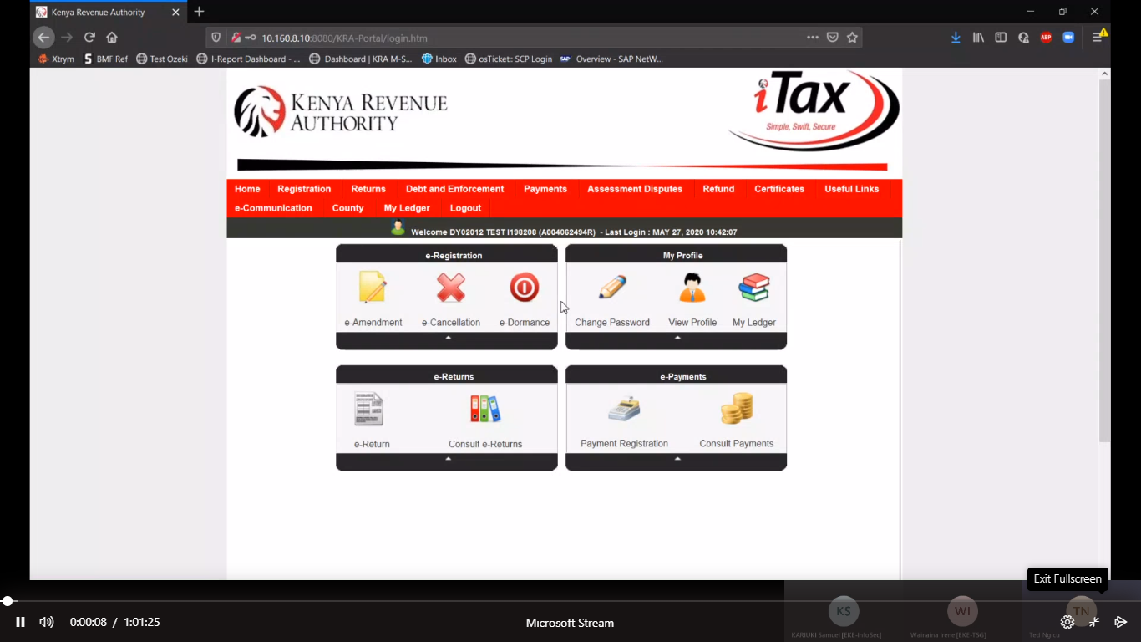

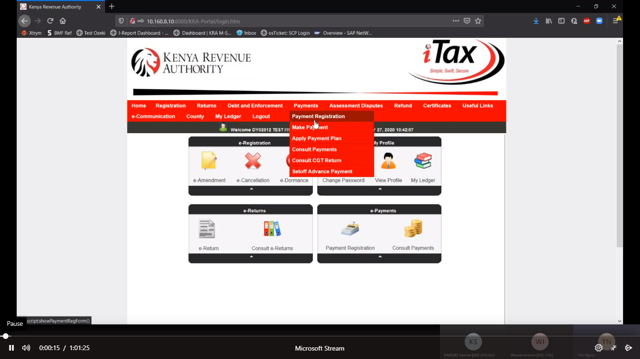

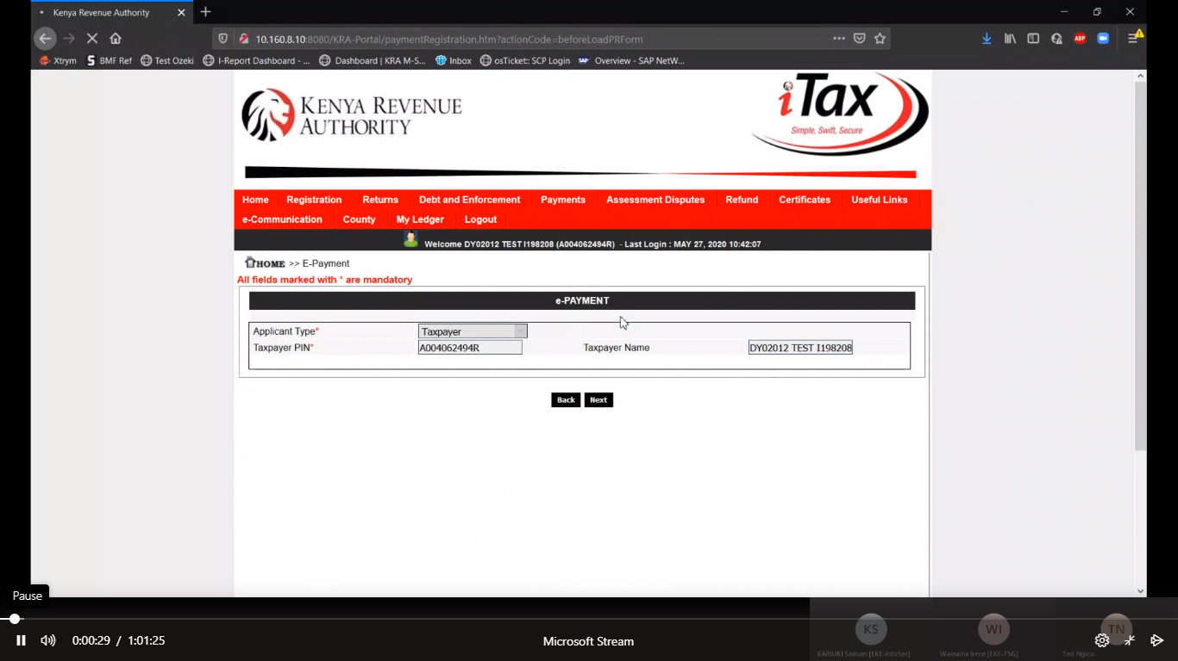

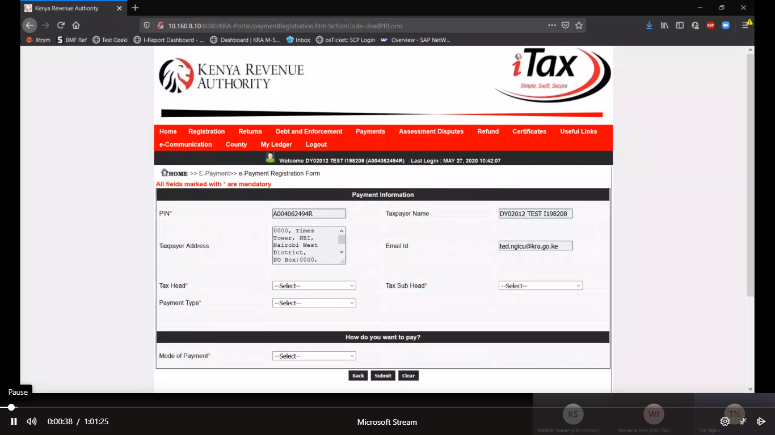

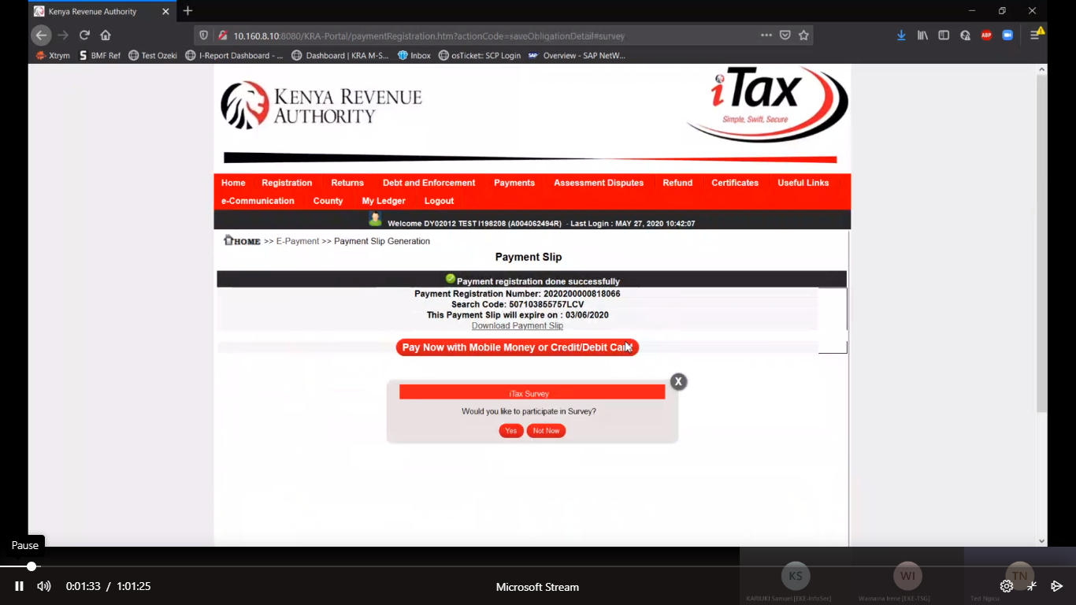

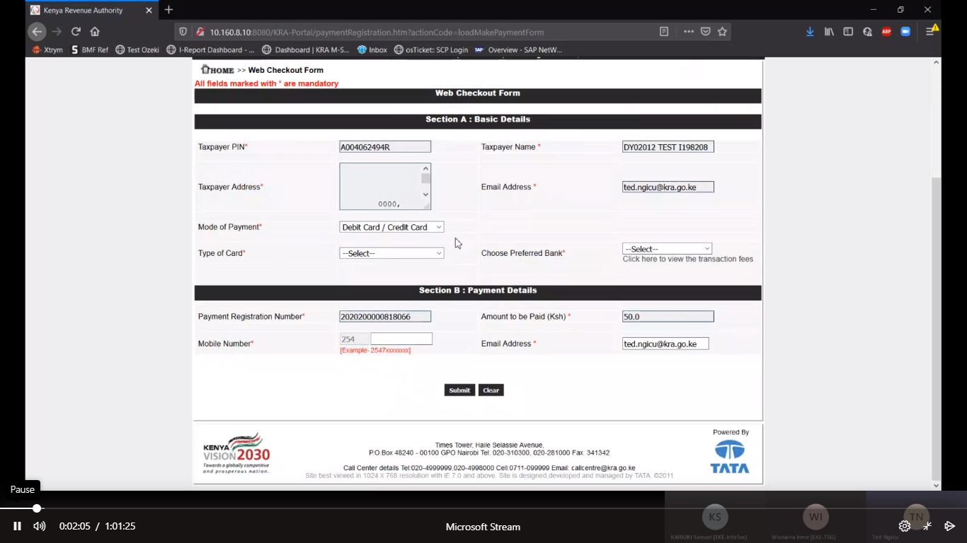

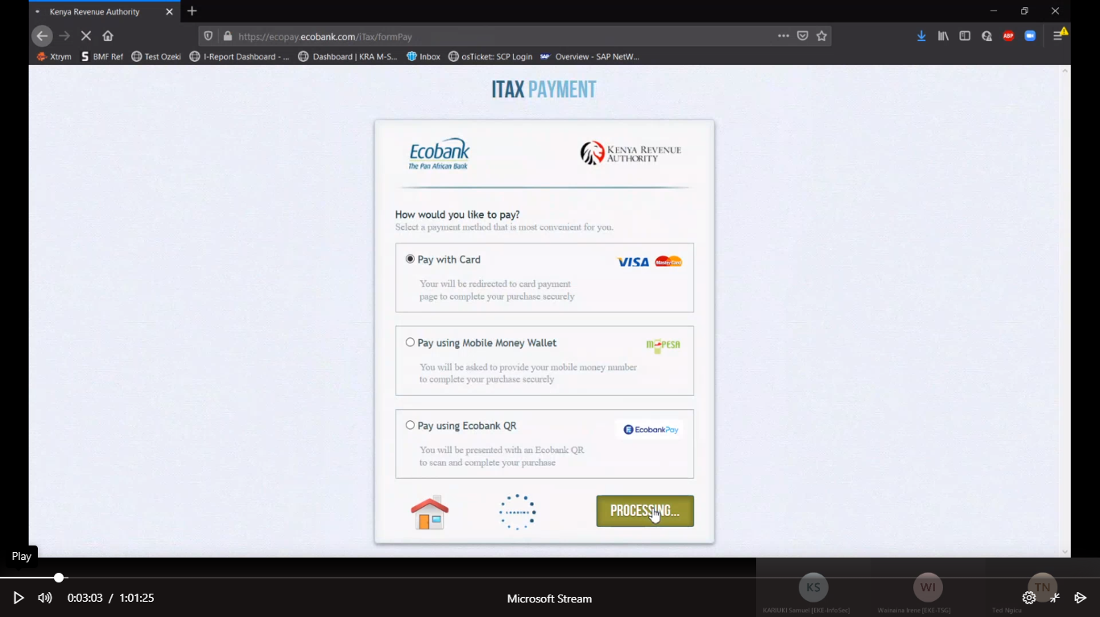

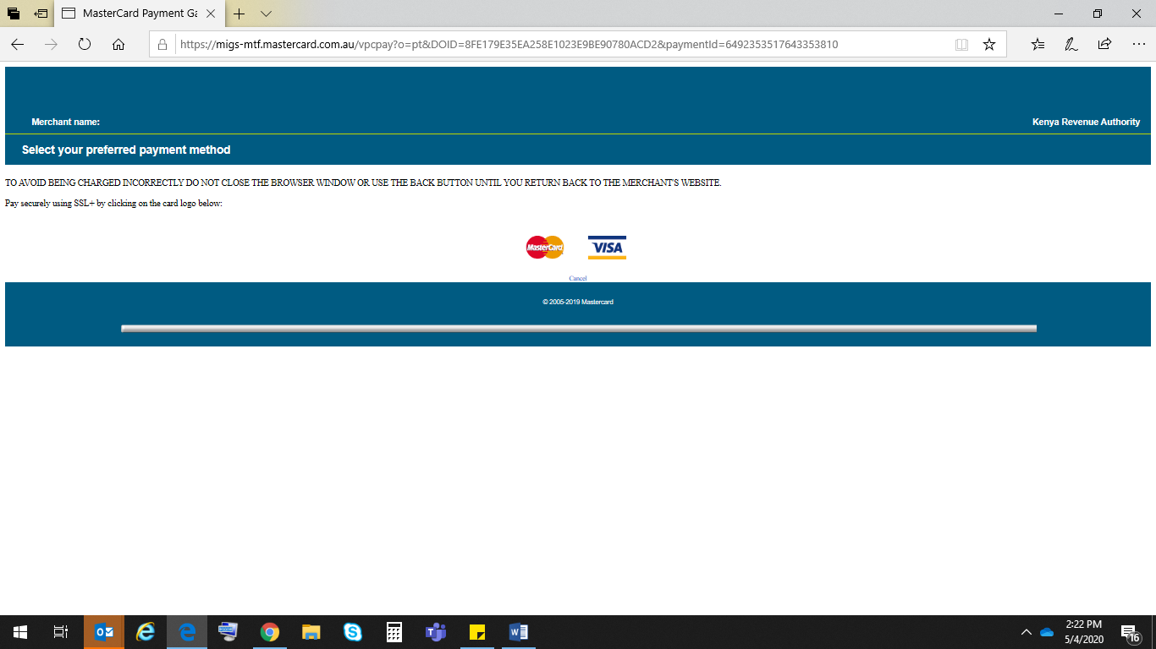

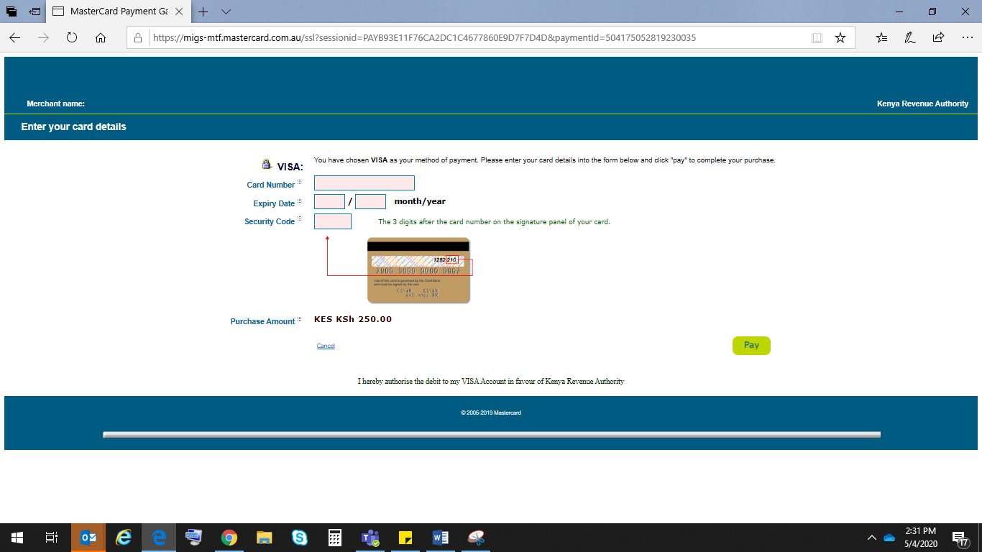

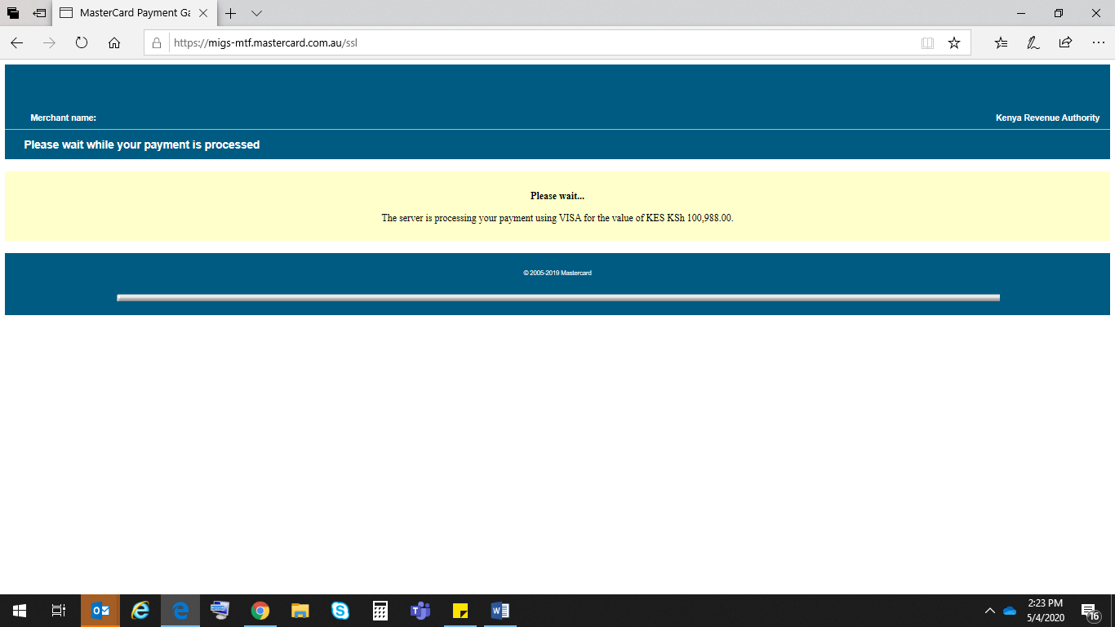

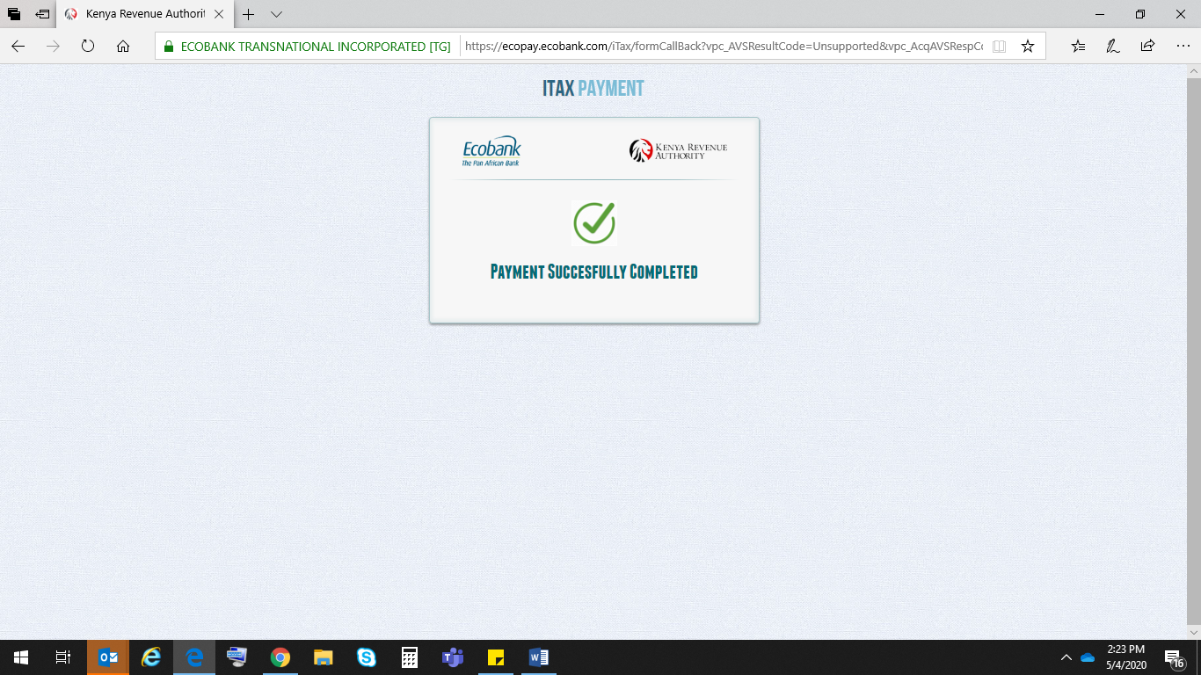

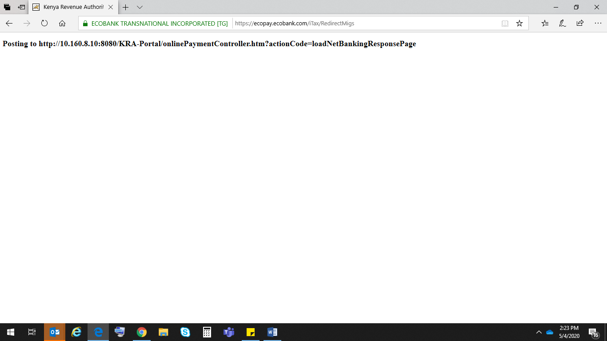

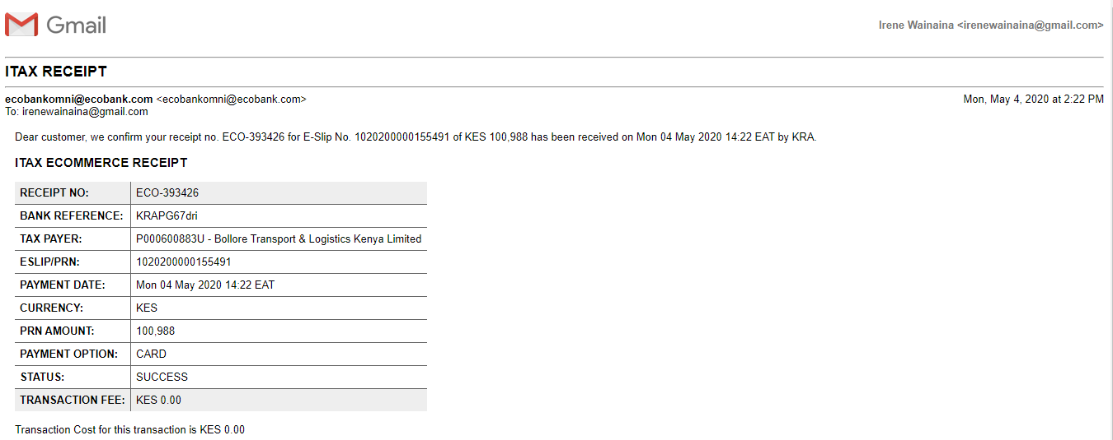

Cancellation from MIGS

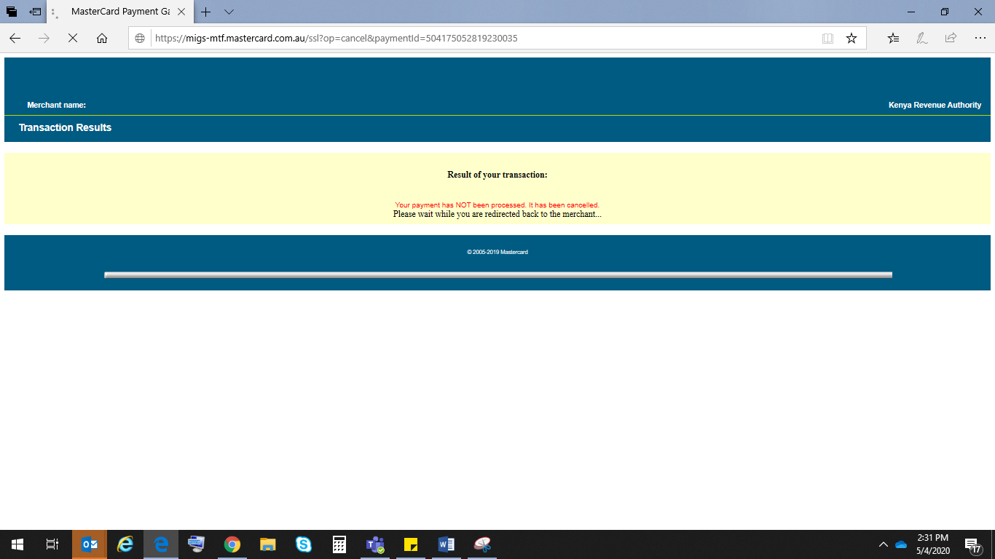

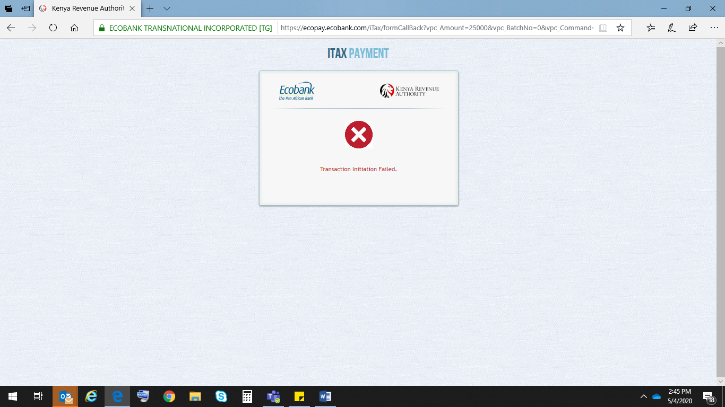

For Transactions where the Eslip has an issue and the bank isn’t able to update;

We display and message for the client, re-direct to KRA, send a message to KRA with a NOK message and send a receipt with needed details as per below screenshots.

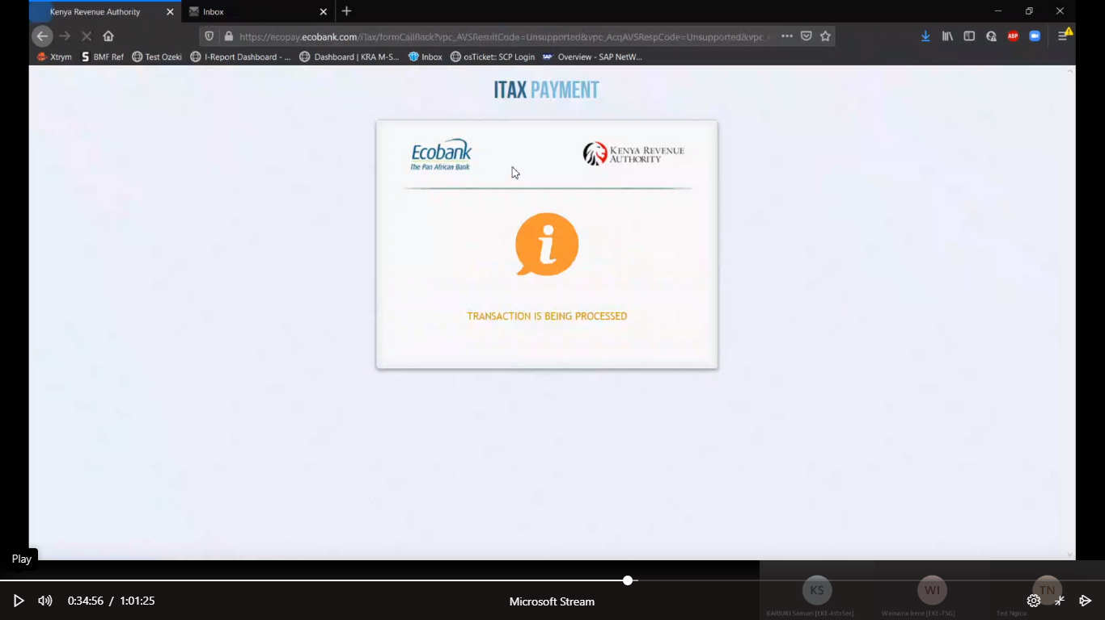

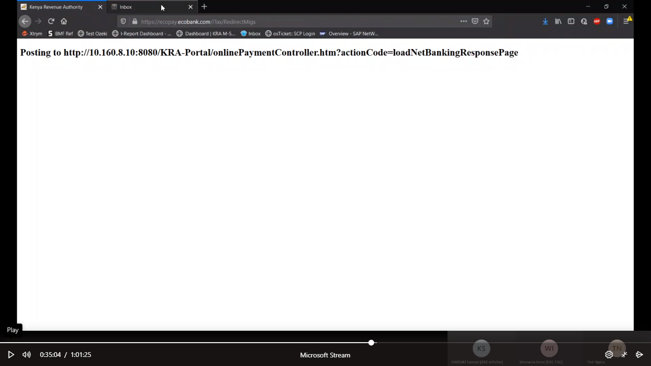

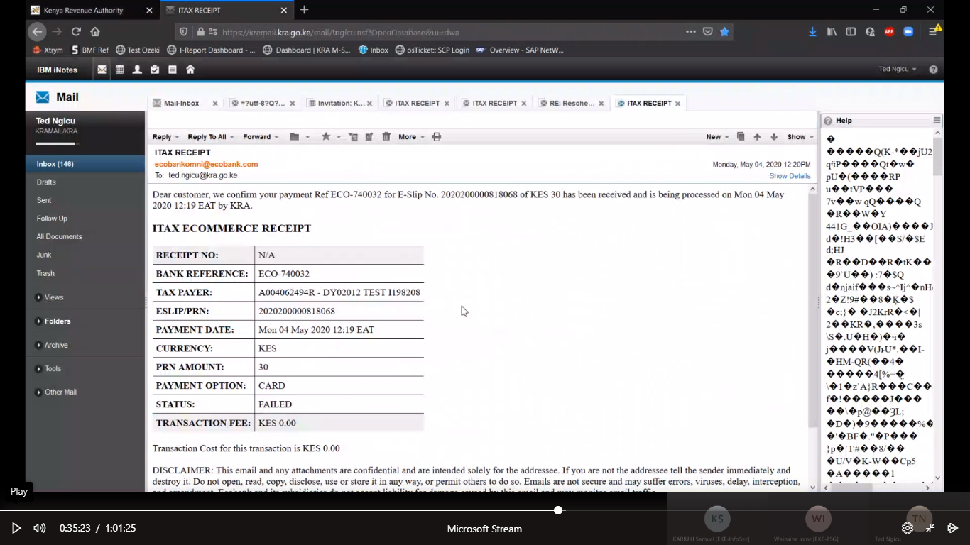

**QR Option:-**

Testing in the QR will be on production since we don’t have a test app to facilitate end to end testing

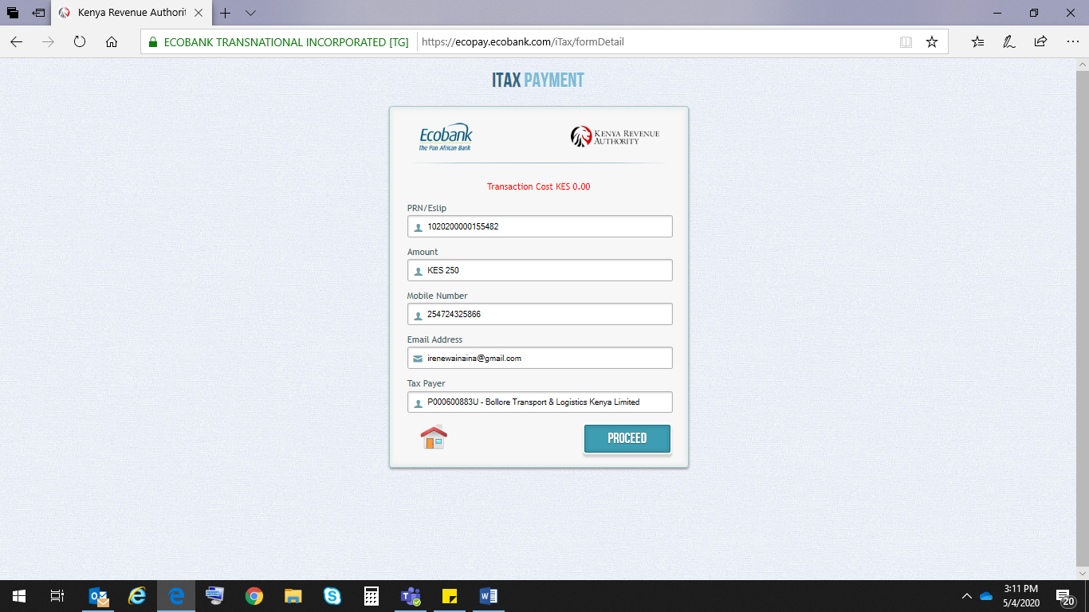

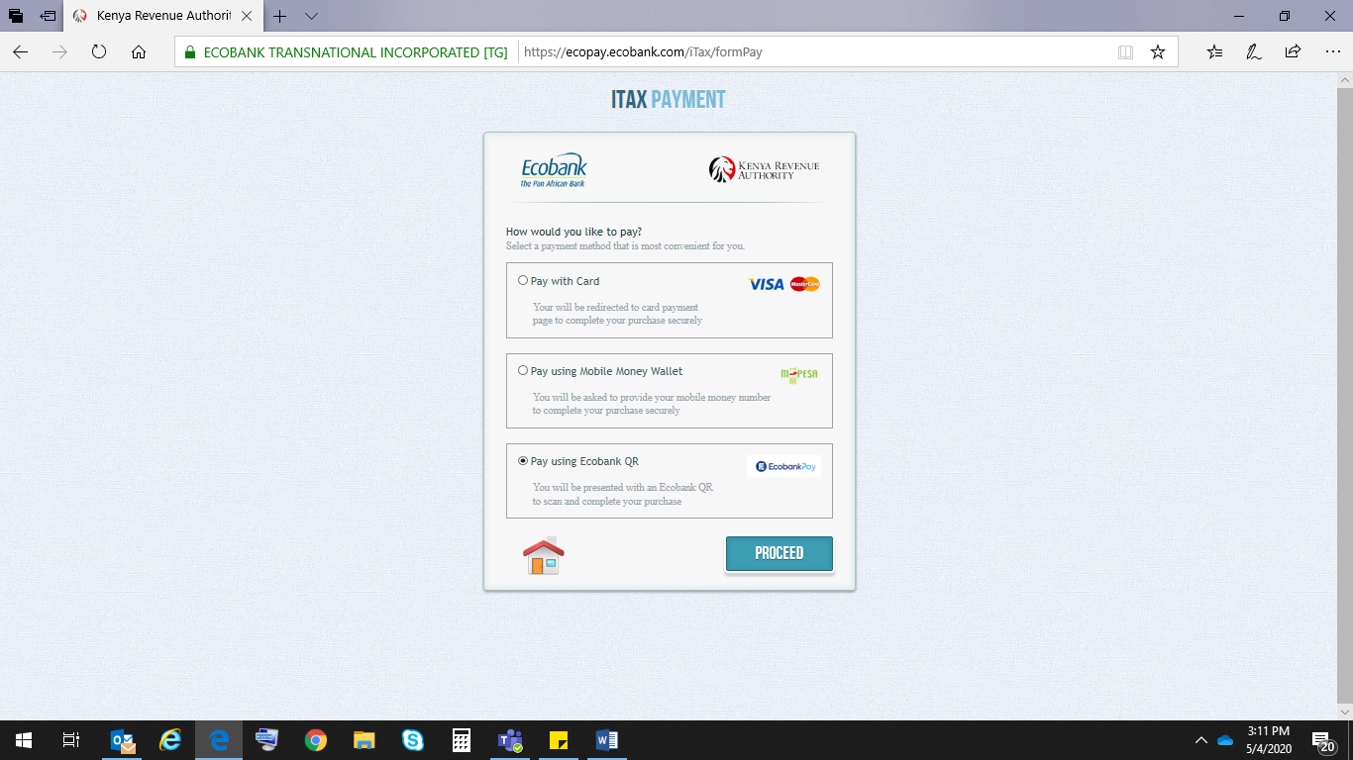 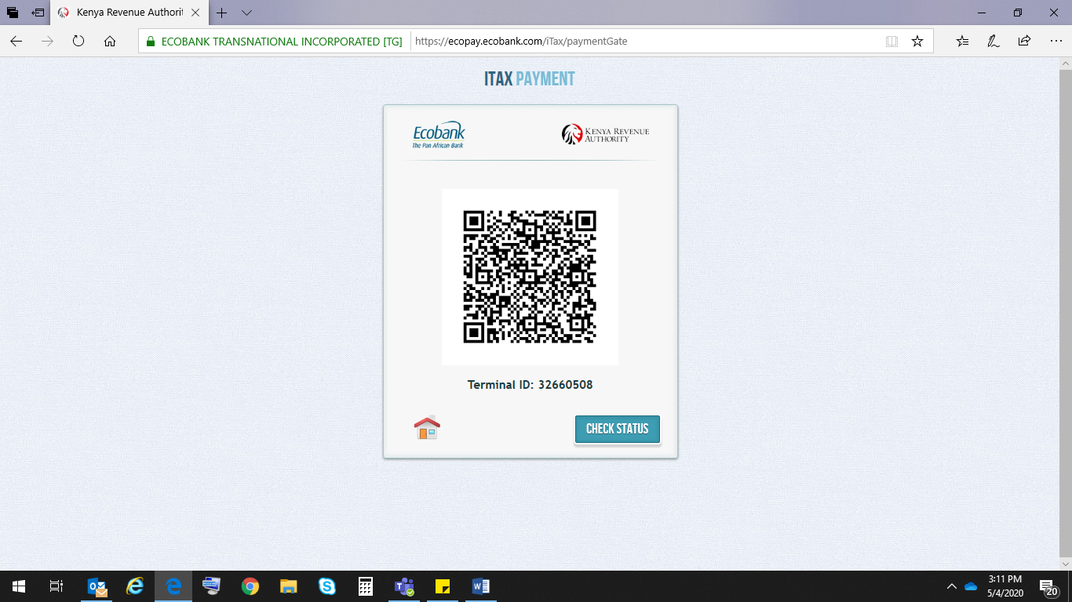

Mpesa Option:

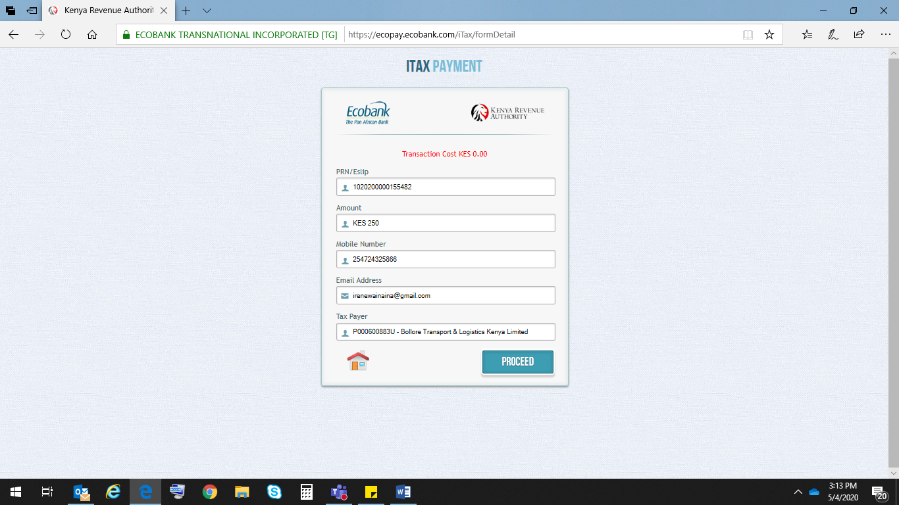

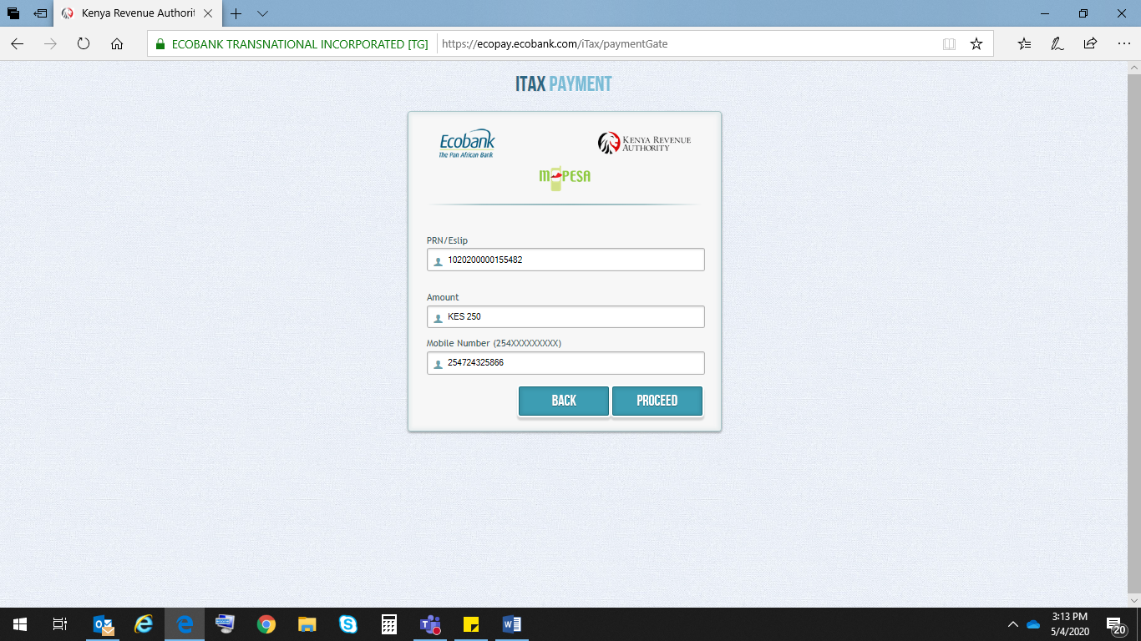

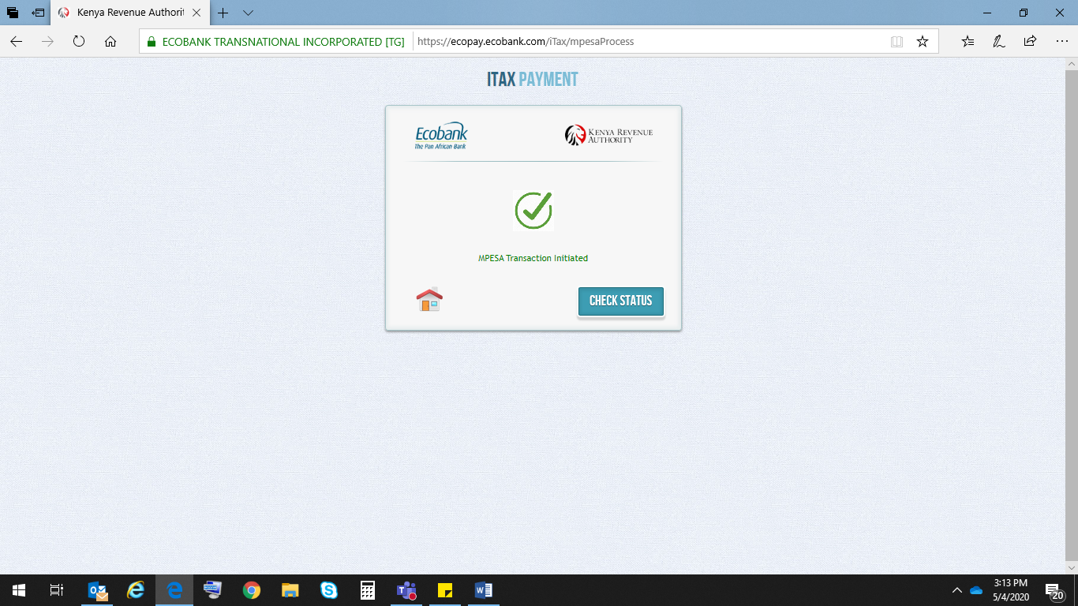

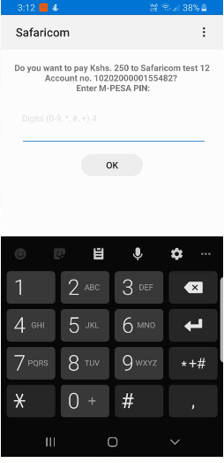

Text message: -



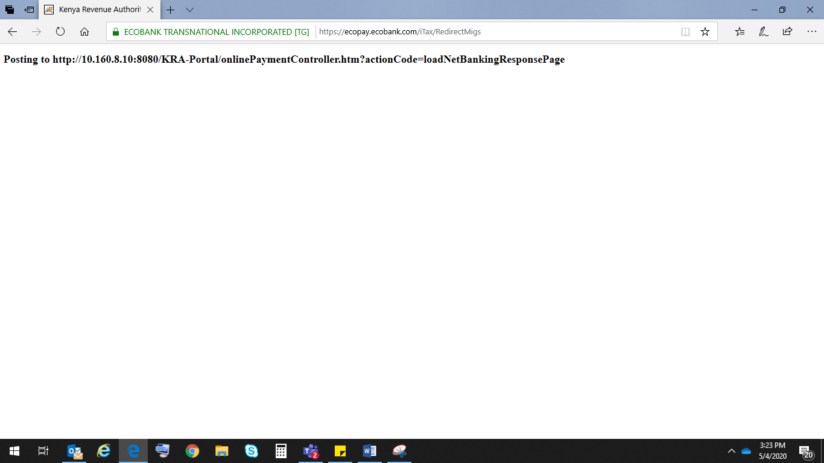

Incase client has insufficient funds;

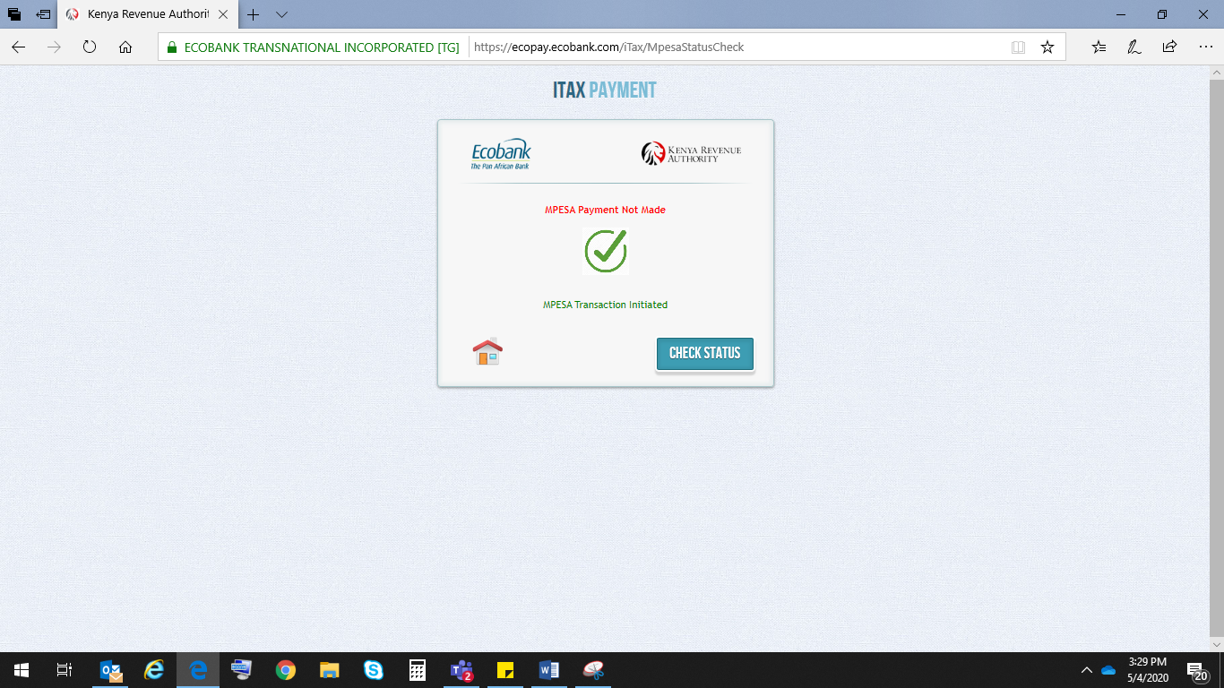

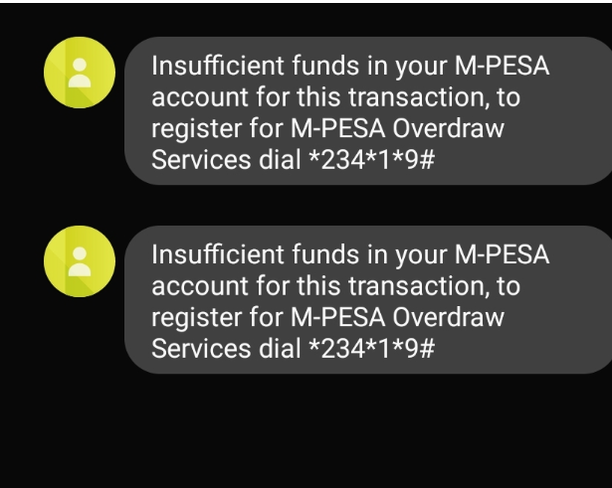

Sign-offs

*Guidelines below should be followed for Test Results Sign-off*

*The signatory shall indicate that the test results have been reviewed and accepted subject to the following categories (A, B, C)*

* + 1. *A – Agree with Test Results*
    2. *B – Agree subject to incorporation by completing the comments column*
    3. *C – Disagree, complete in the comments column*

|  |  |  |  |  |  |
| --- | --- | --- | --- | --- | --- |
| S. No. | Name | Designation | Signature and date | Categories  (A, B or C) | Comment if any |
| 1 |  | Business Unit representative |  |  |  |
| 2 | Samantha Kungu | Affiliate IT Support Staff | 5/5/2020 |  | Ok |
| 3 |  | Group IT Support Staff/ Project Manager |  |  |  |
| 4 |  | Affiliate Internal Control Representative |  |  |  |